实验一 熟悉Visual Studio集成开发环境

# 实验目的

复习程序设计的基础知识，熟悉Visual Studio的使用方法。

# 实验内容

请编写以下2个程序。

## Vedic Square and Vedic Star

**（1）Problem Description**

In ancient Indian mathematics, a Vedic square is a variation on a typical 9×9 multiplication table. The entry in each cell is the digital root of the product of the column and row headings.

Vedic Square是一个9×9的表，与九九乘法表类似。只是表的每个格不是行列序号的乘积，而是乘积的数字根。下图是Vedic Square。

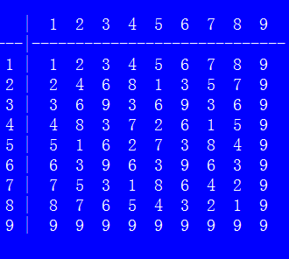

**（2）Vedic Star**

By replacing a specific number by asterisk whereas the others by space within the Vedic square, you can find some distinct shapes each with some form of reflection symmetry.

**（3）Output**

You are to print the Vedic square first, and then the shapes of every specific number. An example of the shape of number 1 is as follows.

  

## Elevator

**（1）Problem Description**

The highest building in our city has only one elevator. A request list is made up with *N* positive numbers. The numbers denote at which floors the elevator will stop, in specified order. It costs 6 seconds to move the elevator up one floor, and 4 seconds to move down one floor. The elevator will stay for 5 seconds at each stop.

For a given request list, you are to compute the total time spent to fulfill the requests on the list. The elevator is on the 0th floor at the beginning and does not have to return to the ground floor when the requests are fulfilled.

**（2）Input**

There are multiple test cases. Each case contains a positive integer *N*, followed by *N* positive numbers. All the numbers in the input are less than 100. A test case with *N* = 0 denotes the end of input. This test case is not to be processed.

**（3）Output**

Print the total time on a single line for each test case.

**（4）Sample Input**

1 2

3 2 3 1

0

**（5）Sample Output**

17 (6 * 2 + 5)

41 (6 * 2 + 5 + 6 * 1 + 5 + 4 * 2 + 5)